TIELMANN DEVELOPMENTS
OFFER TO PURCHASE

I/WE,
(hereinafter called the “Purchaser”) of
Res. Ph. , Bus. Ph. , Cell Ph.
E-mail address:

Hereby offer and agree to purchase through Royal LePage Prime Real Estate/Wayne Penner as agents for Tielmann Developments or a incorporated company yet to be named (hereinafter called the “Developer”) the land known as

Lot No. , Block No. , Plan
, Street Civic Address

In parish of East St. Paul (hereinafter called the “Lot”), which Lot is identified on the plan of subdivision of the development commonly known as Tielmann Developments (the “development”), a copy of a Development portion of such plan of subdivision is attached as Appendix “A” hereto, for an amount equal to the Purchase Price set forth in paragraph 1 below. The Lot shall be free and clear of all encroachments by adjoining structures and from any encumbrances except for any caveat or plan of survey filed or to be filed in connection with, or giving notice of, any rights-of-way or easements related to the installation an maintenance of utility services or as a result of any subdivision agreement, development agreement, building restriction agreement, easement agreement or zoning agreement entered into or to be entered into between the Developer and/or R.M. of East St. Paul (the “municipality”) or related Municipality to any restriction, requirement or standard set out in paragraph 8 herein or attached hereto in Appendix “B”. The subdivision referred to herein is subject to approval of the approving authority on or before the Possession Date (as hereinafter defined).
1. The Purchase Price (the “Purchaser Price”) $ + GST for the Lot

The Purchase Price shall be payable as follows:

a) a deposit to be refunded to the Purchaser if this offer is not
accepted, and if accepted to be applied against the Purchase Price $10,000.00

b) A further deposit $10,000 payable upon the purchaser receiving and
accepting the development agreement from the developer/municipality. $10,000.00

c) by a further cash payment on the Possession Date $ ___
(may be by proceeds of financing or mortgage)

Purchaser Price $_____________+gst

2. The date of possession shall be 20 (the “Possession Date”), which shall also be the date for adjustment of real property taxes and all like matters of adjustment. The Purchaser acknowledges that at the time of conveyance of title of the Lot, the Developer may have only partially serviced the Lot and that additional services may have to be installed. It is however specifically agreed by the Purchaser that there shall be no hold back of funds or trust conditions imposed by the Purchaser’s solicitor on the Developer )or on the Developer’s solicitor), as to the completion of such services.

Should the proposed plan of subdivision not be approved or a building permit or title not be available on or prior to the Possession Date, the Developer may at its option, but without any obligation, extend the Possession Date for such period of time as determined by the Developer, provided that such period shall not exceed the original Possession Date by ninety (90) days, failing which either the Purchaser or Developer may terminate this Agreement by notice in writing to the other and thereupon the Developer shall return the amounts paid on deposit without any liability to either the Purchaser or Developer.

Should the Developer determine in its sole discretion, on or before the Possession Date, the Developer for reasons of weather cannot complete the current stage of the Development, then the Developer may at its sole option, extend the Possession Date to such date as it may determine provided that such date shall not extend beyond ten (10) months from the Possession Date. Notice of such extended date shall be provided by the Developer to the Purchaser in writing and the Purchaser acknowledges that such extended date shall become the Possession Date.

3. The Purchaser shall be liable for and shall pay to the Developer, on the Possession Date, all goods and services tax in respect of the sale of the Lot, unless the Purchaser is a registrant pursuant to the Excise Tax Act (Canada) and provides to the Developer on the Possession Date a duly executed declaration under subsection 221(2)(b) of the said Act.

4. The Purchaser covenants and agrees to comply with and satisfy the requirements on the part of the Purchaser set forth in Appendix “B” hereto-entitled “Tielmann Developments” – Design Control Standards” (the “Standards”) which Standards are by reference incorporated herein and are deemed to form a part of this Agreement. Any reference to Agreement herein shall be understood to include the Standards.

5. The Purchaser covenants and agrees to initiate construction of a single family dwelling upon the Lot within two (2) years of the Possession Date and to substantially complete it within one (1) year of issuance of a building permit. A dwelling shall be substantially complete if it is ready for use, or is being used as, a dwelling.

In the event the Purchaser has not initiated house construction within the said two (2) year period, the Damage and Design Compliance Deposit (as that term is hereinafter defined) shall be forfeited and paid to the Developer. In addition to the forfeiture of the Damage and Design Compliance Deposit, the Purchaser hereby grants to the Developer an option – which may be exercised by the Developer in its sole discretion but the Developer shall have no obligation to do so – to re-purchase the Lot for an amount equal to the original Purchase Price less an amount equal to the Goods and Services Tax and land transfer tax which would be eligible on the transfer of the Lot from the Purchaser to the Developer.

Within fourteen (14) days after the delivery of the Purchase Notice, the Purchaser shall deliver to the Developer a transfer of land, sufficient upon registration in the Winnipeg Land Titles Office to vest title in the name of the Developer clear of all encumbrances, except for caveats or plans of survey filed in connection with rights-of-way or easements related to the installation and maintenance of utilities or as a result of any subdivision agreement, development agreement, building restriction agreement, easement agreement or zoning agreement entered into between the Developer and the Municipality or related to any restriction, requirement or standard set out herein or Appendix “B” attached hereto.

The Purchaser covenants and agrees with the Developer that the Purchaser will not resell any of the Lots covered by this agreement unless the sale of such Lot is complete with a dwelling unit constructed thereon. If the Purchaser is a builder or contractor, the Developer will allow conveyance of the lands to a third party with whom the Purchaser has a written agreement to construct a home on the Lot.
In the event the Purchaser must sell the lot due to unforeseen circumstances, written permission to sell the lot must be received from the Developer. In addition, the Purchaser will grant to the Developer an option – which may be exercised by the Developer in its sole discretion but the Developer shall have no obligation to do so – to re-purchase the Lot for an amount equal to the original Purchase Price less an amount equal to the Goods and Services Tax and land transfer tax which would be eligible on the transfer of the Lot from the Purchaser to the Developer. The Developer may exercise the said option by providing written notice to the Purchaser (the “Resale Notice”) any time following one (1) month after request to resell.
Within fourteen (14) days after the delivery of the Resale Notice, the Purchaser shall deliver to the Developer a transfer of land, sufficient upon registration in the Winnipeg Land Titles Office to vest title in the name of the Developer clear of all encumbrances, except for caveats or plans of survey filed in connection with rights-of-way or easements related to the installation and maintenance of utilities or as a result of any subdivision agreement, development agreement, building restriction agreement, easement agreement or zoning agreement entered into between the Developer and the Municipality or related to any restriction, requirement or standard set out herein or Appendix “B” attached hereto.
6. In addition to the Purchase Price, the Purchaser shall pay to the Developer, on the Possession Date, a damage and design compliance deposit in the sum of FIVE THOUSAND ($5000.00) DOLLARS. The “Damage and Design Compliance Deposit shall be held by the Developer in accordance with terms of this Agreement. The said Deposit will be refunded to the Purchaser, on the date when the Purchaser has completed the approval process and final inspection indicates compliances as stipulated in 1.0 to 8.0 of Appendix “B” all to the satisfaction of the Developer. In the event that the Purchaser does not comply with any covenants, requirements or obligations on the part of the Purchaser contained within the Agreement, the Developer. In the event that the purchaser does not comply with any covenants, requirement or obligations on the part of the Purchaser contained within this agreement, then the Developer shall be entitled, but not obligated, to complete such items which have not been complied with, to such standard as the Developer in its sole and absolute discretion deems satisfactory and to apply the sum of up to FIVE THOUSAND ($5,000.00) DOLLARS to the cost thereof. For the purpose of this paragraph the dwelling constructed on the Lot shall be deemed to be completed if substantially completed within one (1) year of occupancy.
The Damage and Design compliance Deposit (or the balance of such Deposit following such deductions there from as the Developer may be entitled to make pursuant to the provisions of this Agreement) shall be refunded, following the Refund Date, upon receipt by the Developer from the Purchaser (or if the Lot has been sold by the Purchaser, upon receipt by the then registered owner of the Lot) of a request for return of such Deposit provided that such written request is received within 36 months of the Possession Date. In the event the request is not received within 36 month period, then the Damage and Design Compliance Deposit shall be forfeited to the Developer and the Purchaser (or any subsequent registered owner of the Lot) shall have no further right, entitlement or interest in or to the Damage and Design Compliance Deposit.
In the event that the Lot (with house) is sold and transferred prior to the Refund Date then the Damage and Design Compliance Deposit, (or the balance of such Deposit then remaining following such deductions therefrom as the Developer may be entitled to make pursuant to the provisions of the Agreement) shall be paid to the current registered owner of the Lot. The Purchaser acknowledges and agrees that such payment shall satisfy all obligations of the Developer under this paragraph 6 and that the Purchaser shall have no further claim or entitlement in respect of the Damage and Design Compliance Deposit. The Purchaser further acknowledges that any return of the Damage and Design Compliance Deposit shall take approximately one month.
7. The Purchaser shall and does hereby to indemnify and save harmless the Developer from all costs relating to or arising out of any damage:
a) to water shut off valves, hydrants, streets and roadways (including without limitations the, natural gas lines, telephone and communications cables and related works and equipment, hydro, electric lines and related works and equipment, street lights and standards, street name signs and traffic control signs, surveyor’s stakes and monuments or any other service, installation or structure (in this paragraph the “Services”) within, adjacent to or benefiting the Development, that may be occasioned by any act or omission of the Purchaser, or any employee, contractor, subcontractor, agent or assignee of the Purchaser or any person delivering materials or providing services to the Lot; and
b) to lands within the Development caused by any motor vehicles used by or on behalf of the Purchaser in connection with an construction on, or landscaping of, the Lot.
In addition to the aforesaid indemnity, the Purchaser shall immediately upon demand of the Developer, repair at its sole cost and expense, any Services to the same state as before such damage occurred. Should the Purchaser not repair the damages as determined by the Developer, then the Developer may cause the said damages to be replaced or repaired and the Purchaser hereby agrees to pay the cost thereof to the Developer within 30 days of receipt of invoice for such cost. Interest on account of non-payment as stipulated will be calculated at the rate of Eighteen (18%) percent per annum on the unpaid balance. The Developer agrees, on completion of building operations by the Purchaser on the applicable Lot and upon written notice to the Developer by the Purchaser, to make a physical inspection to ensure that no damages remain outstanding respecting the Lot and the adjacent lots thereto.
8. The Purchase covenants, agrees and acknowledges with the Developer that:
a) After the Possession Date the Purchaser will control noxious weeds and will comply in all respects with the requirements imposed upon an owner or occupier of land under The Noxious Weeds Act ( Manitoba) with respect to the Lot and does hereby indemnify and save harmless the Developer from all costs, expenses and penalties imposed upon the Developer in respect thereto. In the event the Purchaser does not undertake appropriate weed control, as determined by the Developer, acting reasonably, the Developer reserves the right to enter upon the Lot and undertake appropriate weed control measures to its satisfaction.
b) No building shall be erected other than one dwelling house with an adjacent attached garage providing for a minimum of two parking spaces within such garage;
c) The dwelling house to be constructed upon the Lot is to be used for single family residence purposes only;
d) No building structure, fixture or erection of any kind shall be erected without the Developer’s and the Municipality’s prior written approval of plan of site, showing setbacks, sides and rear limits;
e) No building waste or other material shall be dumped or stored on the Lot. The Purchaser shall, throughout such times as is reasonable during the construction of the dwelling situate on the Lot and upon substantial completion of construction of the said dwelling, by solely responsible for and shall, at this or her sole expense, remove from the Lot all building waste and materials remaining from construction and all trees, brush or other vegetation destroyed in the course of construction;
f) No animals except household pets shall be allowed upon the Lot;
g) Work on any building may not commence until the Municipality’s engineers have provided grade stakes, which shall be adhered to;
h) The Lot shall not be subdivided for any purpose whatsoever so as to vary the number of building sites;
i) The Purchaser will not apply to the Municipality or any government authority to use the said Lot for a purpose other than a permitted use under the applicable zoning by-laws unless the Developer’s permission in writing is first had and obtained;
j) That all possible steps will be taken by the Purchaser to conserve and stockpile the top soil removed from the Lot and that same will be replaced on the Lot for the benefit of the owner of the swelling to be constructed on the Lot. The Purchaser acknowledges that the Developer has graded the Lot to the Municipality’s requirements. Accordingly the Purchaser shall be solely responsible, at his or her sole cost, to remove any excess fill or provide any additional fill as a result of or in accordance with the requirements of the structure(s) built by or for the Purchaser on the Lot. The Developer will assume no responsibility for lot grading done by the Purchaser;
k) The Purchaser shall not permit occupancy of any dwelling erected on the Lot until the dwelling has been serviced with sewer and water and unless occupancy permits or final inspections are first had and obtained from the Municipality;
l) The Purchaser shall install at their own expense all sewer and water connections from the service to the dwelling to be erected on the Lot, in accordance with the requirements of the Municipality, and shall secure from the Municipality all necessary permits in connection therewith and pay to the Municipality all of their charges therefore;
m) The Developer has no control over Manitoba Hydro, Gas, MTS Communication Inc. wiring services and/or Cable RV boxes which will be placed on the Lot, as such, no representations have been made to the Purchaser in respect to the location of same;
n) This Agreement is subject to the terms and conditions of a Development Agreement entered into, or to be entered into, between the Developer and the Municipality (the “Development Agreement”);
o) In order to ensure that lot grading for homes is undertaken, the Purchaser will be responsible for providing a copy of the site plan, house type drawing, i.e. plans sections and all elevations, to the Developer’s engineers for review and approval. No construction will be commenced on these lots until approval from the Developer’s engineers are received.
p) The Purchaser shall fulfill the following obligations and responsibilities of the Developer as outlined in the Development Agreement, namely:
i) To ensure and mitigate road damage to construction vehicles the purchaser agrees and is responsible that they will take all due measures to ensure all construction vehicles accessing their lot will keep the streets clean from any debris (including, without limitation, mud, dirt or soil) which the Developer has determined, acting reasonably, was caused by the Purchaser or the Purchaser’s contractors, subcontractors, agents, employees or assignees;
q) He/she shall ensure that the Purchaser’s builder complies with all restrictions and obligations of the Purchaser contained herein;
r) The Purchaser acknowledges that there will be a grading plan approved by the Municipality in connection with the Development and covenants to comply with same in landscaping the Lot.
s) The Purchaser shall be responsible for installation and maintenance of silt fences if necessary and other measures of erosion control until acceptable ground cover or permanent structures are established that will preclude the need for temporary measures if necessary.
The Purchaser will grant a Construction Access Easement to the Developer that will allow the Developer and/or its consultants or employees to enter onto the Lot in order to cure any erosion problems resulting from deficiencies in plantings and or silt fences, including the planting of cover crops, erection or silt fences or any other measures required to ensure erosion control.
t) The Purchaser permits the Developer, its servants, contractors and agents the right, with machinery and equipment, entry and access to the Lot to do such work as may be required of the Developer in order that the Developer may carry out its obligations under any Development Agreement, including the building of fencing, etc., or for the purpose of ensuring compliance with and enforcing its rights and entitlements under this Agreement. The Developer and its authorized agents, employees and consultants shall not be liable for any damages sustained by the Purchaser in connection with actions taken by the Developer pursuant to this Agreement;
u) The Purchasers to be aware that future planning of the immediate area may require the closing of Henderson Hwy.in the future and access to be obtained from northern and or southern lands when developed as determined by the municipality planning dept. See Appendix “C”.
9. a) The Developer specifically covenants and agrees that pursuant to Development Agreement, it has agreed to construct, install and complete in a good and workmanlike manner and in accordance with plans of specifications to be provided to the Municipality and approved of by the Engineer for the Municipality, the following services at the Developer’s cost:
i) All roadways to be constructed in accordance with the municipality of East St. Paul
ii) lighting where deemed necessary by the municipality and MB Hydro
iii) clearing of all lots in the Development and ensuring all building sites are to be in a good and tidy and workmanlike manner upon the completion of construction in respect to the Services;
iv) permanent street name signage;
v) signage for road construction vehicles
vi) Hydro, gas, and telephone lines to be installed at the expense of the Developer pursuant to a schedule prepared by Manitoba Hydro. (The costs of such hydro, gas, and telephone installation from the terminus of the extension within the Lot to the dwelling are to be borne by the Purchaser).
b) The Developer represents that Manitoba Hydro will install gas lines within the easement along the Lot line. The Purchaser acknowledges that any connections of gas lines from the terminus of the extension within the Lot line to the dwelling shall be the responsibility and for the cost of the Purchaser.
10. The Purchaser acknowledges and agrees with the Developer that:
In addition to any other provision of this Agreement to that effect, the covenants herein shall run with the land.
11. The Purchaser acknowledges that the Municipality has enacted a sprinkling Bylaw in respect of outdoor lawn sprinklers and agrees to comply with such By-law if applicable.
12. The terms and provisions hereof shall survive completion of the agreement of purchase and sale and not withstanding its completion shall be continued and remain in full force and effect for the benefit of the Purchaser and the Developer and shall not be merged in or superseded by any document, transfer or conveyance delivered by the Developer hereunder or the issuance of title to the Purchaser or any nominee or assignee of the Purchaser.
13. It is specifically acknowledged and agreed by the Purchaser that the Developer herein shall have the right to register a caveat against title to the Lot by way for a Development Scheme Agreement, which caveat shall be registered in series with, and immediately following the transfer of land in connection with the Lot), giving notice of all the terms and conditions herein contained to be performed by the Purchaser after the Possession Date, and that such caveat shall run with the land.
14. Until the Possession Date, the Lot shall remain at the risk and responsibility of the Developer. In the event real property taxes have not been assessed by the Possession Date, the Developer shall be entitled to estimate such taxes for purpose of adjustments and the Developer and Purchaser agree to make such further adjustments as may be necessary forthwith after the assessment has been issued by the Municipality or such other entity which is authorized to assess such taxes.
15. In signing this Agreement the Purchaser relies upon his or her personal inspection and knowledge of the Lot and the surrounding lands independent of any representation made by or on behalf of the Developer. This Agreement constitutes the entire contract and agreement between the Developer and the Purchaser and there are no other terms, provisions, representations, warranties or conditions made in respect of the Lot or the surrounding lands except as expressly set out and recorded herein.
16. Closing of the transaction provided herein shall take place at the offices of the solicitor for the Developer on the Possession Date. In the event that any part of the Purchase Price is to be paid from the proceeds of a mortgage to be arranged, the Developer shall be entitled to file a caveat in series after the transfer of land securing the unpaid balance of the Purchase Price. The transfer of land to be provided by the Developer may, at the Developer’s option, be in electronically produced from provided such form has been previously approved by the Registrar General of the Winnipeg Land Titles office.
17. The Purchaser’s solicitor shall not be entitled to impose any trust conditions upon the Developer, or the Developer’s solicitor, upon closing of the transaction herein except the following:
a) That it will provide the Purchaser’s solicitor with a transfer of land in respect of the Lot in registerable form which, when registered, will result in title issuing in the name of the Purchaser free and clear of all registered liens, charges, mortgages, and encumbrances except those permitted by this Agreement or arising by, through or against the Purchaser or which the Developer’s solicitor has undertaken to discharge;
b) That the Purchaser will receive vacant possession of the Lot on the Possession Date;
c) That the Developer will adjust taxes on the assessment of the Lot directly with the Purchaser.
18. The Developer shall not be required to deliver a declaration commonly known as a “Declaration as to Possession: but herewith represents, warrants and covenants with the Purchaser that now, and as at the Possession Date:
a) It is not a “non-resident of Canada” as such term is defined in the Income Tax Act (Canada);
b) It is the registered and beneficial owner of the Lot and has never been distributed in its possession;
c) It is a registrant for G.S.T. purposes pursuant to the Exise Tax Act (Canada) and shall provide to the Purchaser its GST registration number on the Possession Date. Developer gst #
d) It knows of no claim of any person, corporations, municipalities, or government to or affecting the Lot whether adverse to its title thereto or otherwise, and it knows or no license, tenancy, lease, or agreement for a lease, option to purchase, easement, right of way, judgment, execution mechanic’s lien, charge, mortgage, encumbrance, order under the Bankruptcy and Insolvency Act, agreement for sale or other agreement affecting the Lot except as registered against the title for the said lot or referred to in this agreement except for encumbrances relating to the financing of the project which shall be discharged in connection with Closing of the within contemplated transaction.
19. The Purchaser acknowledges and agrees that, in addition to any other rights or claims available to the Developer hereunder, the Developer shall be entitled to apply to a court of competent jurisdiction for an injunction to prevent any breach or threatened breach by the Purchaser of this Agreement (including, without limitation, the terms of the Standards). In the event the Developer is successful in obtaining such injunction, the Purchaser shall indemnify the Developer for all costs incurred in commencing and maintaining such action.
20. This Agreement, when accepted by the Developer, shall constitute a binding contract of purchase and sale and time shall, in all respects, be of the essence.
21. I/WE hereby make a deposit of in trust payable to the Developer’s agent on account of this purchase, which deposit is to be returned to the Purchaser without deduction or interest if the Developer does not accept this offer by the day of , 20 .
After the offer has been accepted by the Developer, the deposit shall be applied against the Purchase Price when the Developer carries out its obligations under this agreement but to be returned to the Purchaser should the Developer fail to do so.
22. Should the Purchaser fail to comply with the terms of this Agreement, including without limitation the terms of completion of the sale and payment on the Possession Date, the Developer may at its option cancel this agreement and retain the deposit as liquidated damages and not as penalty, or may exercise whatever other remedies it may have a law.
23. The Purchaser agrees to acknowledge receipt of the Development Agreement and further acknowledges that he/she shall read and understand and hereby covenants and agrees that, to the extent such Development Agreement and Design Control Standards are applicable to the Purchaser, he or she shall adhere to and comply with same. The Developer, or its agent, will provide the final Development Agreement to the Purchaser, for acknowledgement when available and the purchasers will have 7 days to accept same.
If the Purchaser is entering into this agreement on behalf of a third party, the Purchaser will obtain written confirmation from the third party that he/she has received the Development Agreement, and acknowledges that he/she has read and understands and hereby covenants and agrees that, to the extent such Development Agreement and Design Control Standards are applicable to the Purchaser, he or she shall adhere to and comply with same.
24. This agreement is terminated unless the following conditions for the benefit of the Purchaser are fulfilled or waived;
a) that any mortgage shown as to be arranged can be so arranged by the Purchaser by
day of , ; and

b) (Others – if no others, state “none”)

Date at the City of Winnipeg, in Manitoba, this day of , 20

X
Witness Signature of Purchaser

X
Witness Signature of Purchaser

Solicitor for Purchaser:

ACCEPTANCE
The Developer hereby accepts the above Offer to Purchase and agrees to and with the Purchaser to duly complete the sale on the terms and conditions above mentioned. Should the Developer fail to do so the Purchaser may (at his or her option) cancel this agreement and withdraw his or her deposit.
The Developer agrees to pay Royal LePage Prime Real Estate, a broker’s commission of (state in terms of percentage of purchaser price or dollars, any alternate commission arrangements must be stated( and directs and authorizes Royal LePage Prime Real Estate to retain and apply the cash deposit or so much thereof as is required to pay the said commission as and when such deposit become property payable to the Developer and hereby irrevocably directs and authorizes its solicitors to promptly pay and unpaid commission out the said proceeds.

Dated at the City of Winnipeg, in the Province of Manitoba, this day of , 20 .

Tielmann Developments Ltd.
Per:

Per:

APPENDIX “A”

Tielmann Developments
LOT SKETCH

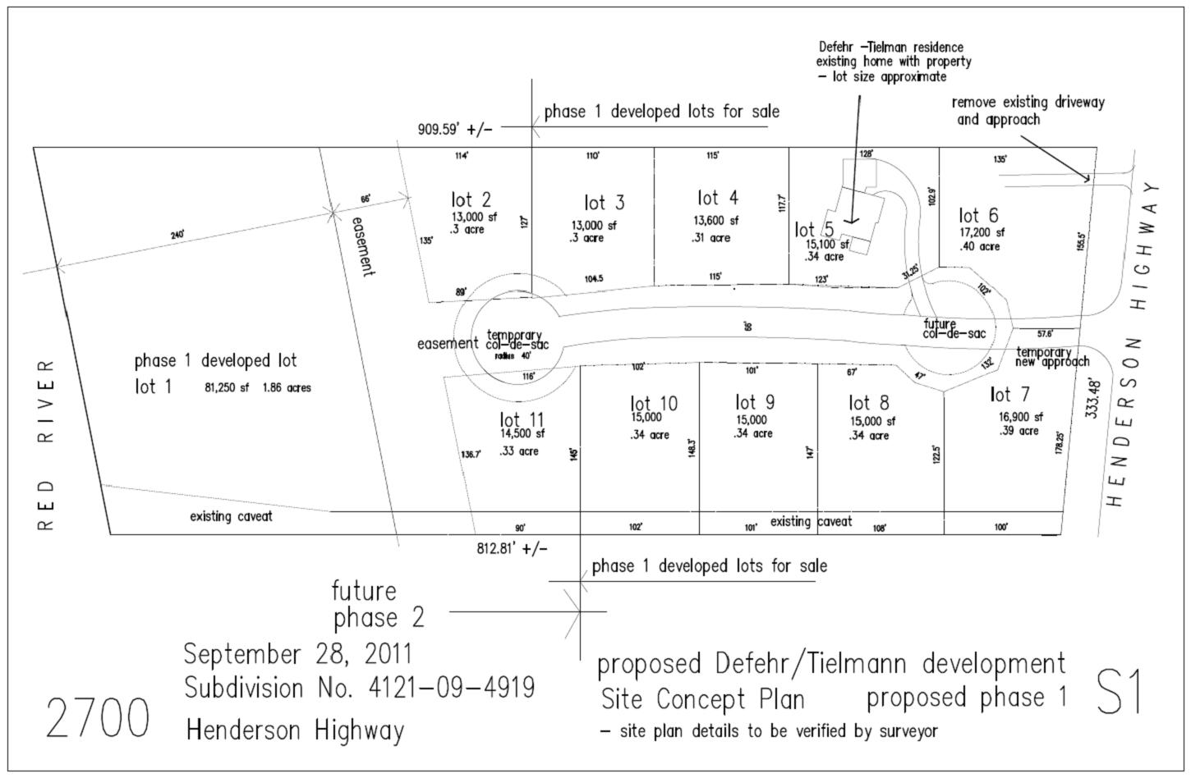

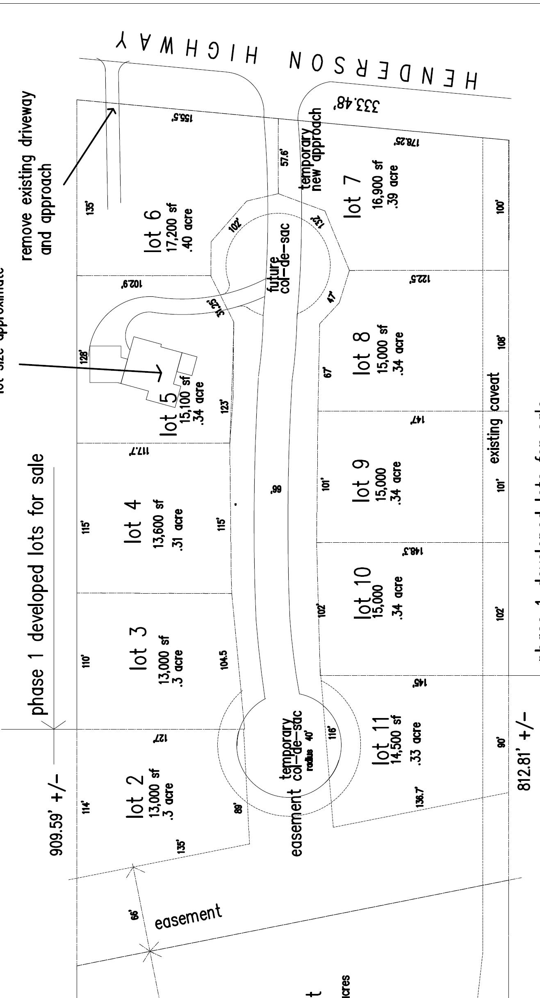
APPENDIX “C”

TIELMANN DEVELOPMENTS
Future planning detail

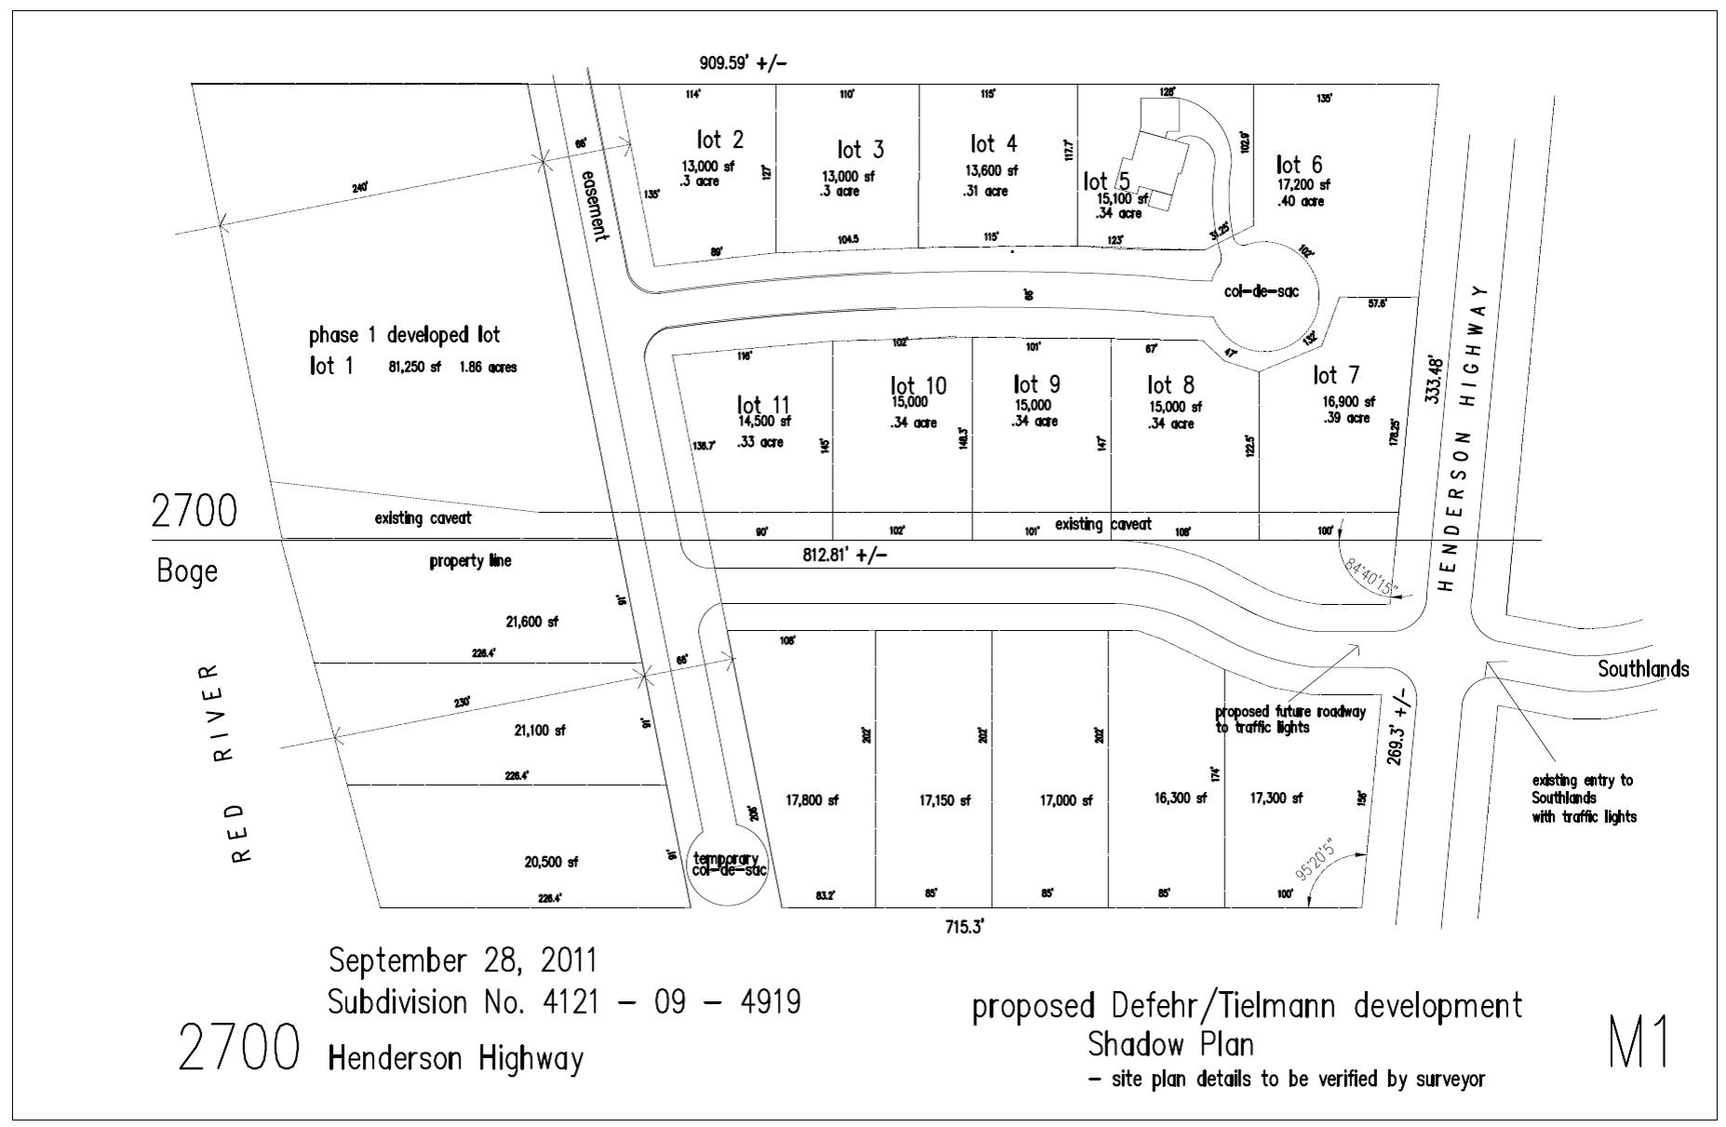

Proposed Front Lots

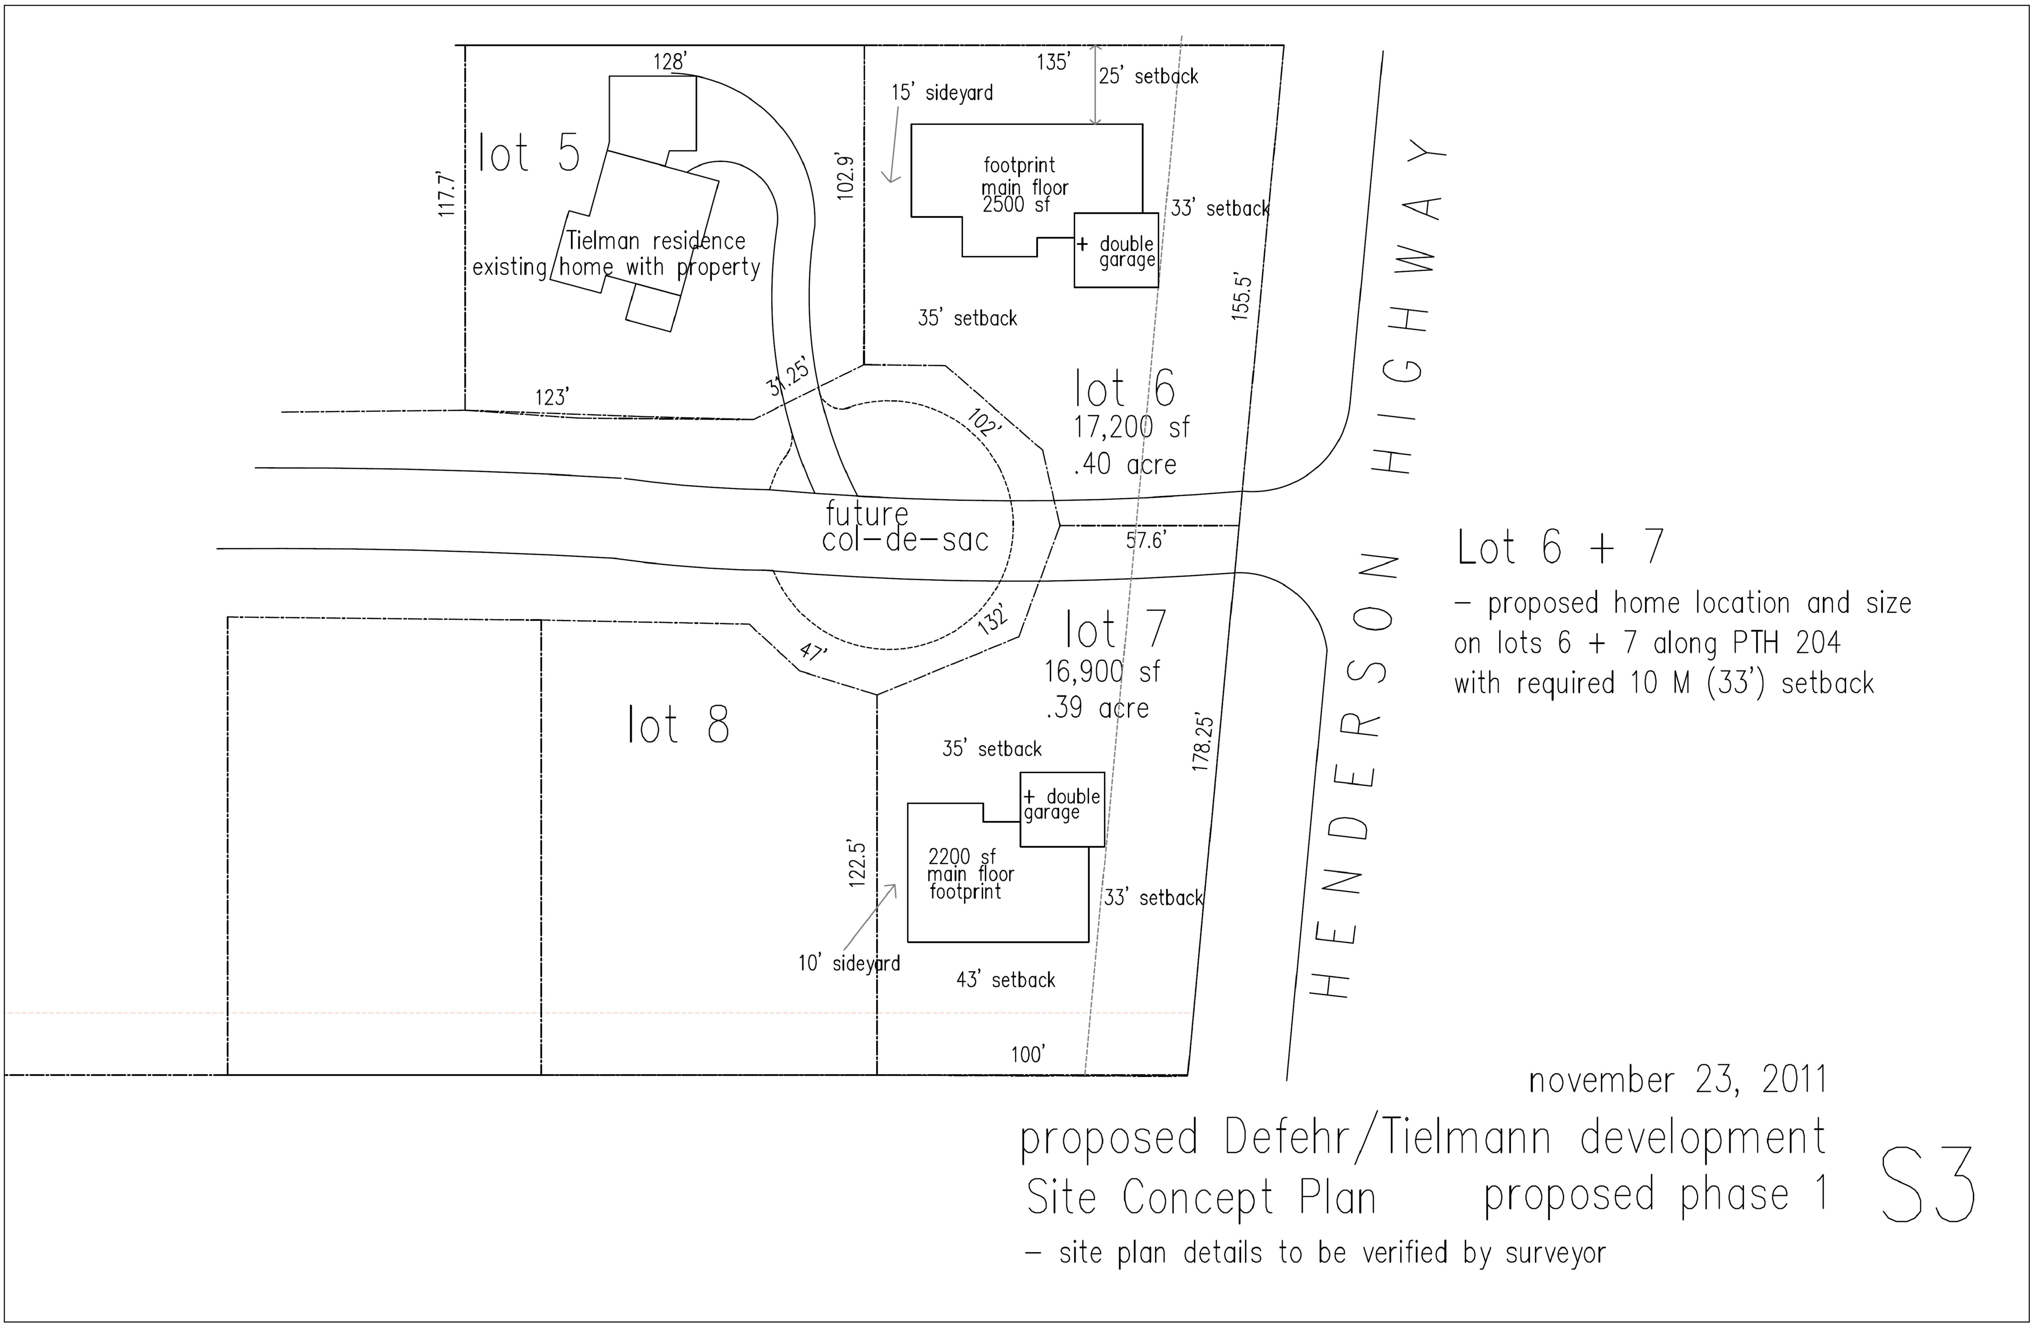

APPENDIX “B”

TIELMANN DEVELOPMENTS
DESIGN CONTROL STANDARDS

- Introduction
The Purchaser acknowledges that compliance with the provisions of these Design Control Standards (the “Standards”) and cooperation with the Developer in site inspections which the Developer shall conduct, are necessary and desirable to ensure that all properties conform to the vision of the Development. The Purchaser further acknowledges that the terms contained herein are necessary in order to help preserve the integrity and character of the Development. The Purchaser and all its successors in title hereby covenant and agree to comply with all provisions and obligations on the part of the Purchaser contained herein.
  - Design Standard Objective
It is the intention of the Developer to ensure a well coordinated, attractive subdivision through the adherence to these Standards so that an appropriate standard of architectural design and materials throughout the community including all aspects of site development, landscaping, fencing and exterior finishes is maintained.
The requirements of these Standards are in addition to any restrictions or requirements in connection with the Lot as may be required by the Municipality.
The Developer (which term in these Standards shall include, where appropriate, its agents, consultants (design or otherwise) or employees) either directly or through its agents or employees, will verify satisfactory compliance to these Standards and has the authority to reject unsatisfactory housing proposals or recommend changes required to comply with these Design Control Standards. The Developer will make inspections during the construction process, and a final inspection upon completion of each dwelling or structure on the Lot to ensure that such dwelling or structure is constructed according to approval granted by the Developer. Infractions noted at this time by the Developer will be penalized by full or partial loss of the Damage and Design Compliance Deposit. The Purchaser shall immediately cease conducting any additional work in connection with the subject matter giving rise to the infraction until such matter has been resolved to the satisfaction of the Developer.
It is understood that the responsibility and costs of complying with these Standards shall be borne by the Purchaser and/or builder.

It is the responsibility of the Purchaser and builder to check and verify all information and ensure that the required controls documentation has been completed prior to construction.
- DESIGN STANDARD
  - Architectural Theme
These Standards, together with thoughtful designs, will promote a concept of housing designs that will compliment each other, with the result being a community of homes that add value to each other and to the community of East St. Paul.
2.1.1 General
a) Continuity of design, detail, and materials on exterior elevations will be approved by the Developer.
b) All residences shall be designed to include a minimum two-car attached garage. No carports, detached garages or detached workshops are allowed.
c) No residence shall exceed two stories in height when viewed from the street. Minimum roof slopes of not less than 7-12. Exceptions will be considered for roof slopes consistent with acceptable styles.
d) Minimum house width shall be 60 feet.
e) The lot and building requirements specified by the Developer in the original agreement shall be adhered to by the Purchaser or successor in title.
2.2 Setbacks and Yard Requirements
2.2.1 The minimum setbacks required by the Municipality shall apply, except where exceeded by the setbacks and yard requirements as determined by the Developer and set out in these Standards.
2.2.2 Front yard setbacks shall be a minimum of 40 feet, maximum 50 feet from the nearest point of the front property line.
2.2.3 Side yard setbacks shall be 10 feet. Corner lot side yards shall be 15 feet.
2.2.4 Rear yards shall be minimum 25 feet. Setbacks and yard requirements shall be measured from property lines to exterior face of building. Encroachments such as cantilevers, bay windows, chimneys and overhangs into the setback are permitted but must comply with the Municipality regulations.
2.2.5 Requests for adjustments on setbacks must be addressed to the Developer during the preliminary design process. The Developer has the option of approving setback changes during the preliminary design process on lots with limited depths. Any reductions to setbacks less than the Municipality’s standards may also require a Municipal variance.
  - Minimum Floor Areas
2.31 Areas shall be calculated at main floor level only for bungalows and bi-levels. Areas shall be calculated as total developed floor areas above ground for one and one half storey units, split-levels, two storey/split-levels and two storey units.
Garage, porches and decks shall be excluded from all floor area calculations. The following list indicates minimum square footage requirements for homes. No objection will be made to increase these floor areas.
Bungalow – minimum area of house 1,700 square feet
Split-level – minimum area of house 2,200 square feet
Two-storey- minimum area of house 2,200 square feet
2.4 Corner Lots and Feature Lots
2.4.1 Houses on corner lots must have similar treatment on elevations exposed to both streets. One storey elevations on flanking streets are required. Additional window glazing on side elevation is required. The Purchaser is required to maintain both the frontage and flankage boulevard to the street curb.
2.4.2 In order to benefit corner lots and the Development in general, the corner lots may be subject to the placement of a decorative corner monument on the property, to be maintained by the Purchaser. Placement of any corner monument is at the option of the Developer and will be placed at the cost of the Developer during the Development construction phase. These structures must be incorporated with a front drive proposal into the site plan submitted for permit process by the contractor/homeowner.
2.4.3 Feature lots are lots that have a major impact on the entrance to a street, a significant viewpoint on a street, or lots with houses that have side and/or rear elevations exposed to public spaces. These lots will require enhanced design on these highly visible elevations. Attention must be paid to materials and details on these secondary elevations to ensure a high level of architectural interest and quality from every viewpoint throughout the neighbourhood.
Prominent rear elevations must echo elements from the front elevation – the home must be designed as a well-considered whole Deck placement, window patterns, wall and roof forms, railings and trims must be considered.

2.6 Lot Grading
2.6.1 Lot grading must follow the natural land contours and must be consistent with the subdivision concept-grading plan as directed by the Municipality
2.6.2 Each lot in the Development must be graded to handle all storm water falling within property lines without draining to adjacent lots.
2.6.3. Each principal residence constructed on each lot within the Development shall provide weeping tile drainage to a constructed sumphole and the discharge of all weeping tile drainage shall be discharged into a two cubic meters rock-filled sump at the rear of the lot. No weeping tile drainage or storm water eaves trough drainage shall be discharged into the sanitary sewer system.
2.6.5 No berms are permitted along property lines which create water run-off onto adjacent properties.
2.7 Exterior Materials
2.7.1 Permitted exterior materials include clay brick, vertical or horizontal wood or vinyl siding, acrylic stucco, stucco, stone, and combinations of the above.
2.7.2 On residences utilizing clay brick veneers in combination with either stucco or siding, finish colours are to be chosen to ensure complementary colour palettes and colour contrasts between materials.
2.7.3 Exterior materials used on principal elevations should be carried around corners to side elevations a minimum of 2 feet.
2.7.4 One cladding material must be predominant on the front elevation and cover at least 60% of the façade. If stucco is the predominant material on the front elevation, additional attention to detail must be given to other non-stucco elements. Additional attention to the use of details and trim complementary to the house style will be expected and required.
2.7.5 All fascia is to be a minimum 7 ½ inches. Dimensions of soffit and fascia to be appropriate to house style.

2.8 Roofs
2.8.1 All roof structures are to utilize a slope of not less than 7-12. Exceptions will be considered for roof slopes consistent with acceptable house styles. Flat roof designs may be permitted with developers approval. Acceptable roof finished include asphalt shingles, cedar shingles, cedar shakes, concrete or slate tiles.
2.9 Driveways
2.9.1 Not more than one driveway shall be constructed for each dwelling and the driveway shall not have more than one access to street per lot. The placement of driveways shall be approved by the Municipality.
2.9.2 Permitted materials for driveway construction include interlocking pavers and cast-in-place concrete, gravel/limestone or combinations thereof.
2.9.3 All approaches and driveways shall be surfaced with concrete or interlocking brick in accordance with the standards required by the Municipality’s engineer. All approaches and driveways are to be completed with 18 months if issuance of building permit. Limestone approaches during construction of home may be required as per municipal requirements.
2.10 Exterior Colours
2.10.1 All exterior materials and related colours are subject tot review by the Developer or its consultants and specific samples and colour chips maybe requested and kept to confirm compliance with approved colour schemes on site.
2.10.2 Colours for roof, siding and trim must be coordinated for each unit to compliment the individual house design and achieve a harmonious visually attractive effect. Repetition of principal colours or colour combinations on front elevations of adjacent houses will be reviewed. Colours and materials of houses will be controlled to avoid visually disruptive contracts in the streetscape and provide a varied but harmonious ensemble of housing units.
3.0 FENCING AND LANDSCAPE ARCHITECTURE
3.1 Fencing
3.1.1 Fencing is permitted only in the rear yard and is to be constructed a owner’s expense.
3.1.2 Additional privacy on all lots can be achieved by planting trees and hedges.
3.1.3 Any fencing to be installed in areas that are open to public view shall be permitted subject to written approval from the Developer prior to installation. Failure to receive written approval may result in the Developer removing the fence at the owner’s expense and deducting costs in connection with such removal from the Damage and Design Compliance Deposit.
3.1.5 Fence Design
a) Definitions:
i) Solid Design Fence will consist of solid wood fencing to a maximum height of six feet.
ii) Open Design Fence will be either black vinyl-coated chain-link fencing or black wrought-iron look fencing to a maximum height of five feet.
b) Flanking Lots (Corner Lots)
Open Design Fence is permitted to a maximum of five feet in height along the street side.
The Developer reserves the right to accept alternative fence materials and/or designs if at its sole discretion the alternative fence material achieves the intent of these Standards.
3.2 Plant Materials and Landscaped Architecture
3.2.1 Applicants are encouraged to develop plans, which preserve existing trees.
Landscaping should include, at a minimum:
- sod, plants, a minimum of 2 trees and shrubbery for front yard including boulevard to the street curb – see 3.2.3
- Front yard and flankage landscaping to be completed within eighteen (18) months from commencement of construction.
3.2.2 Corner Lots
In addition to the general landscaping guidelines in 3.2.1 above the homeowner is required to sold and maintain the flankage boulevard to the street curb.
    - Boulevards
Homeowner shall maintain boulevard trees on boulevard, which trees shall be installed by the Developer as required by the Development Agreement. The Homeowner will install and maintain boulevard sodding to the street curb. Additional planting and/or landscape features on the boulevard shall be permitted only after plans have been submitted an approved in writing by the Municipality.
    - Front Yard
No wood decks/patios are permitted in front yards.
    - All swimming pools, decks, patios must be located in the rear or side yard portion of each lot and must be screened from public view from street side. Approval from the Developer is required for the location of deck and pools prior to receiving a permit from East St. Paul.
4.0 MISCELLANEOUS RESTRICTIONS
4.1 Satellite dishes, if erected on individual lots, must be sited completely within the rear portion of the lot and be screened from public view from streets and parks. On flanking lots satellite dish must be located along interior property line away from street.
4.1.2 No recreational vehicles, trailers, boats, commercial vehicles nor any form of trailers, shall be permanently stored in the front yard of any property between the building line and the curb, but a recreational vehicle may be parked in fenced side yard a minimum of 5 feet from property line.
4.1.3 Freestanding garden/utility sheds and or outbuildings, if constructed, must be located only in the rear area of the Lot and must be consistent with the exterior materials and colour schemes for the principal residence. On flanking lots garden/utility sheds must be located along interior property line away from the street. Prefabricated metal/vinyl construction pre-packages are discouraged. Maximum size 800 sq. ft. with maximum height 4.57m (15ft).
4.1.4 No person shall make a building permit application for, or commence construction of, any dwelling or dwellings upon any of the lots until the person has submitted to the Developer complete plans and specifications as required by these Standards.
4.1.5 The Developer reserves the right to refuse any plan which lacks attention to these Standards.
4.1.6 The Developer reserves the right to allow changes from these Standards in cases where such an exception is deemed appropriate and will not detract from the quality of the Development.
4.1.7 Nothing herein contained shall be construed or implied as imposing on the Developer any liability in the event of noncompliance with or non-fulfillment of any of the covenants, conditions, or stipulations herein contained, or contained in any conveyance or other agreement pertaining to any of the lots.
4.18 Nothing contained in this paragraph 4 shall be construed as imposing any liability upon the Developer fro damage resulting from structure defects in any structure erected on any lot with approval nor any responsibility in connection with the site selected for any structure by any owner nor for the determination of lot boundaries.
4.1.9 The Developer, nor any of their respective agents, servants and employees shall be liable for any or all loss, costs, liabilities, claims, damages or injury to any person arising out of:
a) The approval or deemed approval of any building plans, or
b) A failure to enforce any of the provision herein contained; and whether caused by the negligence or willful act of the Builder, the Developer or any of their respective directors and officers, agents, servants or employees or otherwise (herein collectively called the “Liabilities”). Each of the owners of the lots from time to time hereby releases jointly and severally the Builder, the Developer, and each of their respective directors and officers, agents, servants and employees, in respect tot the Liabilities.
5.0 RESTRICTIONS DURING CONSTRUCTION
5.1 Appearance During Construction
5.1.1 All building sites are to be kept safe and orderly during construction. All garbage is to be stored out of sight or disposed of in garage dumpsters. No garbage/trash burning is permitted at any time. Storage or dumping of debris on adjacent lots is not permitted.
5.1.2 Exterior work/construction is permitted only between the hours of 7:00 a.m. and 8:00 p.m., Monday through Saturday, unless special arrangements have been made with the Municipality.
5.2 Signage
5.2.1 All temporary promotional signage is to be approved prior to installation by the Developer.
6.0 APPROVAL PROCESS
Step One Read Standards
Become familiar with Standards.
Step Two Meet with Designer
Your personal design criteria, together with these Standards, will form the basis for the design of your house. As you begin your design process, particular attention should be given to site, location, contour and orientation.
Step Three Submission #1

Preliminary Plan Approval

When meeting with Developer’s consultant to obtain initial approval, the following should be made available:
- Site plan – scale min 1” = 30’
- Floor layout including square footage
- House elevations, including front, side (for corner lots) and rear (for walkout lower level homes)
- Completed Architectural Approval form (see attached) detailing all colours and materials, if available.
If Preliminary Plan meets guideline criteria it will be approved at this time. If Preliminary Plan requires modification to meet criteria a meeting will be set up with homeowner/builder to discuss required changes.
Step Four Submission #2
Final Plan Approval
Submit three (3) complete sets of working drawings that include but are not limited to the site plan (i.e. plans sections, building details, all elevations), grading plan and a completed Architectural Approval from (see attached) indicating all colours and materials to the Developer or Design Consultant. In addition, the Purchaser will be required to submit a colour sample board that will be returned to the Purchaser, upon approval.
The Developer or its Design Consultant reserves the right to request electronic drawing files be provided in addition to the complete set or working drawings.

Step Five Final Approval
Prior to final approval, the Purchaser acknowledges that he/she shall have installed the limestone approach as required pursuant to the Development Agreement, which approach has been approved by the Developer.
Upon submission of plan to the Developer for approval, please expect three to five business days for approval process to be completed. The approval process shall require additional time in respect of lots with walkout basement dwellings.
Approval of your plan will be given to you in writing, along with an approved set of plans. Once approval is given, two approve copies, together with an approval letter and a copy of your acknowledgement indicating that you have received a copy of the Development Agreement, should be taken to East St. Paul for building permit application. The Developer, will retain one copy for its files.
One set of plans is to be retained by the Developer. One set will be stamped “APPROVED” and will be accompanied with an approval form. Both the approved set of plans and the approval from is to be presented to the Municipality upon applying for a

building permit.
  - Pre-plotting of more than two adjacent houses shall submit one (1) copy of the composite plot plan (1”=30’) along with one (1) copy of house type drawings, i.e. plans, sections, and colour sample board, all elevations, completed application form (attached) for each house to the Developer at the address given above.
  - Application for a building permit may be made only after applicant’s completed approval form has been approved by the Developer. The approval process will require five working days for most applicants.
  - Failure to conform to siting, house design, materials, colours or any other portion of the drawings and documentation as approved without the written consent of the proposed revision by the Developer is prohibited.
  - The Developer will provide a final inspection upon completion of each house to ensure that each house is built as it was approved and landscaping completed or note any infractions thereof. Following this inspection the owner shall receive full or partial refund of the Damage and Design Compliance Deposit. The Developer shall determine, acting reasonably, if any matter is not incompliance with these Standards or any approval provided by the Developer. In the event of such non-compliance, the Developer shall be entitled to deduct and retain such amount of the Damage and Design Compliance Deposit as the Developer determines appropriate in the circumstances, which determination shall be final and binding on the Purchaser. In the event of any inconsistencies between the provision of these Standards any approval executed by the Developer, the provisions of the approval shall govern.
- ACCESS
The Purchaser permits the Developer and its authorized agents, employees and consultants entry and access to the Lot for the purpose of ensuring compliance with and enforcing its rights and entitlements under these Standards). The Developer and its authorized agents, employees and consultants shall not be liable for any damages sustained by the Purchaser in connection with the actions taken by the Developer pursuant to this Agreement.
- CESSATION OF DEVLOPERS OBLIGATIONS
The Developer’s obligations and responsibilities under these Standards shall cease and be of no further effect thirty-six (36) months following the Date of Possession of the last lot for sale in the Development. Notwithstanding the cessation of the Developer’s obligations, the Purchaser (and any successor in title) shall continue to be bound by the provisions of these Standards.

APPENDIX “F”
Royal LePage Prime Real Estate - Agent Disclosure and Privacy Consent
In a real estate transaction, you the consumer can choose to have an agent represent you. Our code requires us to fully disclose in writing the nature of our service to our clients versus the other party to a transaction.
Once an agent client relationship has been established we will protect and promote your best interests as we would our own. This would include the following:
1. Loyalty – to serve your best interests ahead of anyone else’s, including our own and at all times to exercise good faith and to disclose all known facts and information which may influence your decision.
2. Obedience to follow all lawful instructions
3. Discretion to keep confidential your private circumstances, motivations, and confidences which you shared with the agent or which we have learned.
4. Competence to exercise reasonable care and skill in performing all assigned duties
5. Accounting of all moneys, deposits, or other property entrusted to us.
In Manitoba generally the seller is represented by an agent who acts in the best interests of the seller. The buyer is generally represented by an agent who looks after the buyers best interests. If an agent represents both parties an “Acknowledgement of Limited Joint Representation” form should be signed. If someone is not represented by anyone an agent would still be responsible to treat them honestly, fairly, and with care and skill.
We value your privacy! Protecting your privacy: it’s our business
To operate a successful full service real estate company we require a variety of information about your property if you are selling, and if you are buying we require other information. Any information is never sold and is passed on only with your consent e.g. real estate boards, banks, insurance company, etc.
A multiple listing agreement will ask for consent to distribute listing information deemed important to market your property and for the retention of that data for statistical purposes and the like. Similarly Royal LePage Prime Real Estate hereby asks for your consent to collect and distribute information to our network and retain that information for statistical, historical and marketing purposes including keeping in contact with you during and after any transaction. If purchasing a property, information will be collected and used for purposes consistent with the services Royal LePage provides in connection with the purchase or prospective purchase of property, possibly including distributing the information to banks and the like, insurance companies, and appraisers, utility firms, etc.
Any consent you give can be withdrawn at any time by contacting the Royal LePage Prime privacy compliance officer at 989-5002, rlp@shaw.ca or your agent.
Should you have any questions or concerns regarding privacy you may contact our designated compliance officer 989-5002.

We hereby acknowledge the receipt and understanding of this Royal LePage Prime document and ___ consent ___do not consent to the collection and retention and distribution of relevant information regarding our contemplated real estate transaction.
We also acknowledge that Royal LePage Prime Real Estate, will be representing the Developer and does not represent the Purchaser(s)
Dated this ____ day of ______________, 20 ____.

___________________________ ____________________________
Purchaser Signature Purchaser Signature

